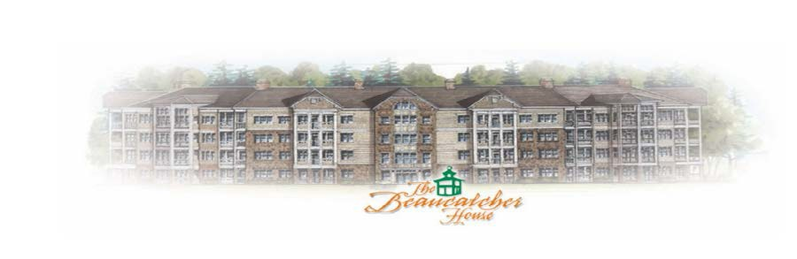

November 27, 2020

The Board and I wish to thank everyone for doing their part in helping to make Beaucatcher House a safe place to live during these difficult times. It has not been easy living through a pandemic and almost everyone has stepped up to the plate. Kudos to you!

That being said, because of the pandemic we only addressed emergencies during Phase I and II and some items such as painting went on the back burner. One of the things that we did do was stretch the carpet in the second and fourth floor lobbies which was greatly needed. We had an issue with honey bees nesting in the outdoor, first level stone pillars the past two years and they have been plugged up to avoid that happening in the future. The coping repair for the pool was completed and the back deck, North side was stained and tracking strips were placed on this set of steps.

Lined up for the close of 2020 (good riddance!) is the steam cleaning of all lobby furniture, elevator ceilings replaced, interior painting of the lobby, basement, first and second floor (North hall) walls, some lobby furniture refinished and glass protective tops have been ordered.

In 2020, the primary focus has been increasing the reserve account and this year, we have maintained our budget and transferred $110,000 into the reserve account. The total amount in the reserve account at the close of 2020: $235,466.00. In the 2021 proposed budget (attached), the total amount to be transferred to the reserve account is $90,000 and will increase our reserves to $325,466.00 at the close of 2021.

Additionally, some items for the 2021 budget include $15k for the repair of A/C cribs on the roof and first floor condensate lines, plus $40k for the repair and staining of the decks within phases.

We can all do our part in helping to maintain the building even if its just avoiding banging a wall, picking up a piece of paper and picking up after your pet, etc. Please remember this is money coming from your HOA dues, and, therefore, out of your wallets! The Board and all the residents appreciate and thank those who help and send a huge thank you to Jimmy Mann for his gardening and decorating skills.

The Board wishes you all the very best for a healthy and happy 2021.

Susan B. Cobb, HOA President

