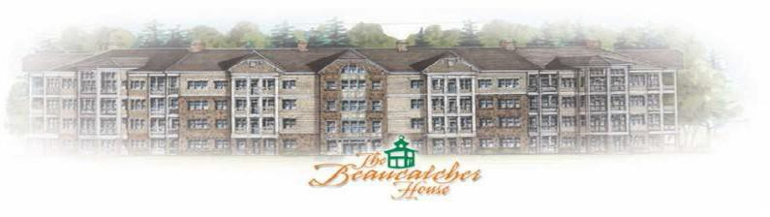

BEAUCATCHER HOUSE HAPPENINGS
www.beaucatcherhouse.com Phone: 828-333-4404
November 2019 Vol. 5 Issue 11

Roof!
We are still waiting for the roofing company to do their final walk through, once completed, we will begin dry wall repair.

Manager’s Hours:
Monday: 9-1pm
Wednesday: 9-2pm
Friday: 9-3pm

Sue Cobb can also assist after hours.
828.778.2020

BOD Meeting for Nov.
** The Next Board of Directors Meeting will November 21st at 4:30pm in the Manager’s office. If you have any items for the Agenda, please submit those via email to Susan Cobb by November 14^{h}. Susancobb@beverly-hanks.com **

Reminder (lobbies)!
Per the rules and regulations, lobby use is only for residents gathering with other residents. This includes all the lobbies within the Beaucatcher House.

Holiday Party!
The Holiday party is scheduled for Saturday, December 15th, details to follow.

Maintenance!
The Beaucatcher House no longer is contracting for full time, on-site maintenance. You may notice some new vendors on-site. If you have a maintenance concern regarding a common or limited-common area, please call Cedar at 877.252.3327, or email maintenance@mycmg.com. They are equipped to send out the appropriate vendors, even after hours.

Budget Time!
Please be reminded, that grills, TV’s and lawnmowers are not permitted in the dumpster area. The association must PAY MONEY that is not budgeted to have these items removed as our service is not regulated to take such items. This cost can be charged back to the unit owner. Please dispose of your items properly. Additionally, every scratch and dent that occurs to the building must be compensated for by your COA fees.

HVAC!
Please be reminded that the attics are locked, and PRIOR (1 week) arrangements must be made with property management to have the attic unlocked for a non-emergency. Please be mindful of your volunteer board members when asking them to unlock the attic, without PRIOR notice.

