BEAUCATCHER HOUSE HAPPENINGS
www.beaucatcherhouse.com Phone: 828-333-4404
September 2019 Vol. 5 Issue 9

Dumpster Reminder!
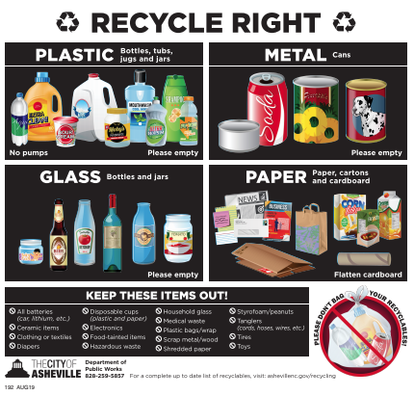

Manager’s Hours:
Monday: 9-1pm
Wednesday: 9-2pm
Friday: 9-3pm

Sue Cobb can also assist after hours.
828.778.2020

BOD Meeting for Sept.
** No BOD meeting this month**

Smoking!
Please be reminded that smoking is only allowed inside your individual unit, or at least 50ft from the building. Please remind guests and vendors of the same. Please continue to dispose of cigarette butts accordingly.

Bears!
Thank you for your cooperation in removing bird feeders. We haven’t had any bear sightings recently.

Pet Waste Reminder!
Please continue to pick up after your pet, thank you!

HVAC Being Serviced?
Please notify property management with one week’s notice when you are having your HVAC serviced. Attic access is necessary and must be coordinated with property. management.

