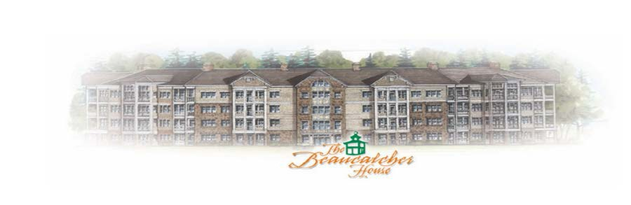

**BEAUCATCHER HOUSE HAPPENINGS**

[www.beaucatcherhouse.com](http://www.beaucatcherhouse.com) **Phone: 1-877-252-3327**

**September 2017 - Vol. 3 Issue 9**

Dear Beaucatcher Residents:

Please do NOT place a lockbox on the bicycle rack in front of the building without Management permission, or it will be removed and disposed of. A Realtor with a listing in the building CAN put their lockbox on the rack.

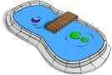 The Pool will remain open until there is a Cold Snap; the Spa will remain open until after the first of the year.

We are very excited to announce that the newest REVISED Rules and Regulations are completed and will be distributed via email in the coming week; and, for those without email, they will be mailed via snailmail. They will also be posted on the Beaucatcher website, [www.beaucatcherhouse.com](http://www.beaucatcherhouse.com), and on the Cedar Resident Portal at [www.web.mycmg.com](http://www.web.mycmg.com).

The next Board of Directors Meeting will be September 28, 2017 at 5:30pm in the Manager’s Office on the Basement Level*.* If you have an item for discussion and wish to schedule community time at the meeting, please contact Susan Cobb at susancobb@beverly-hanks.com by September 20th or earlier. Please include a description of the topic.

