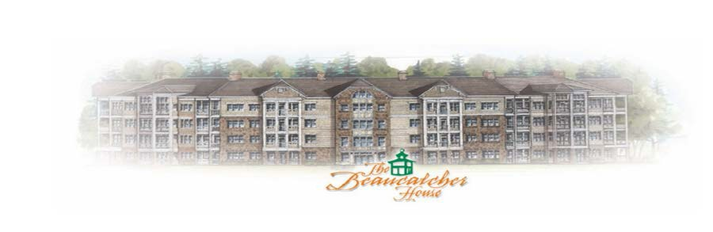

BEAUCATCHER HOUSE HAPPENINGS
Phone: 1-877-252-3327
WEBSITE: BEAUCATCHERHOUSE.COM

October 2016 - Vol. 2 Issue 10

Dear Residents,

The September Board meeting was held at rescheduled date of Sept 29th. There was no quorum for meeting to be held at original scheduled time.

No SKATEBOARDING in Lobby

The pool is now CLOSED. Pool cover will installed this week. The spa will remain open until further notice.

Please note that the Trash receptacles have been removed and discarded. Remember to take your trash with you.

Please note that the attic access entries will be locked. All owners will need to schedule a time with Miranda to allow access to your vendor/contractors doing work. To schedule access you will need to email your request to mshelton@mycmg.com. Scheduling times will be made within normal business hours M-W-F from 9am to 2pm. It is imperative that the contracted technician NOT step off of the catwalk. There are sprinkler lines in these non-catwalk areas. If a sprinkler leak occurs after his service because it has been stepped on, the charge will be assessed back to the homeowner! The average cost to repair these sprinkler leaks is $2000.00. Resident will be responsible for cleanup of any/all material/insulation debris that may fall out into the hallways made by vendor.

The bear remains to be a frequent guest here at Beaucatcher. Please just be aware of your surroundings and DO NOT FEED and make sure all trash is picked up and food inside.

Parking Reminder: Please note that all visitors/vendors MUST park in the marked “VISITOR” section of the parking lot. TOWING IS ENFORCED and will be towed if car is not stickered and not in a visitor parking spot. It is the responsibility of the owner to disclose this parking policy to all potential buyers. Stickers are available in the office during normal business hours M-W-F from 9am to 2pm.

The next board meeting will be September the 28th at 6:00 pm in the Manager’s office. If anyone wishes Community Time, please email susancobb@beverly-hanks.com by the 17th with a brief description of what you wish to discuss.

