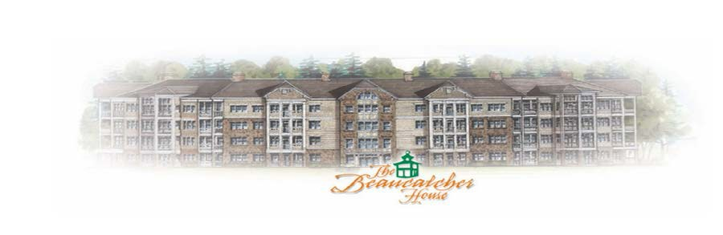

BEAUCATCHER HOUSE HAPPENINGS
Phone: 1-877-252-3327
WEBSITE: BEAUCATCHERHOUSE.COM

NOVEMBER 2016 - Vol. 2 Issue 11

Dear Residents,

The October Board meeting was not held. There was no quorum for meeting to be held at original scheduled time.

Holiday Party date and time will be forthcoming

Please note that the attic access entries will be locked. All owners will need to schedule a time with Miranda to allow access to your vendor/contractors doing work. To schedule access you will need to email your request to mshelton@mycmg.com. Scheduling times will be made within normal business hours M-W-F from 9am to 2pm. It is imperative that the contracted technician NOT step off of the catwalk. There are sprinkler lines in these non-catwalk areas. If a sprinkler leak occurs after his service because it has been stepped on, the charge will be assessed back to the homeowner! The average cost to repair these sprinkler leaks is $2000.00. Resident will be responsible for cleanup of any/all material/insulation debris that may fall out into the hallways made by vendor.

Parking Reminder: Please note that all visitors/vendors MUST park in the marked “VISITOR” section of the parking lot. TOWING IS ENFORCED and will be towed if car is not stickered and not in a visitor parking spot. It is the responsibility of the owner to disclose this parking policy to all potential buyers. Stickers are available in the office during normal business hours M-W-F from 9am to 2pm.
*2017 Parking Stickers will be available next week.*

Office Hours for November: Office will be open Monday- Nov 7th, Wednesday-Nov 9th and Thursday-Nov 10th from 9am to 2pm. The following week office will be open Tuesday-Nov 15th, Wednesday-Nov 16th and Friday-Nov 18th from 9am to 2pm. Office will be closed on Friday, November 25th in observance of the Thanksgiving Holiday.

The next board meeting will be November 24th at 6:00 pm in the Manager’s office. If anyone wishes Community Time, please email susancobb@beverly-hanks.com by the 17th with a brief description of what you wish to discuss.

